

Nubia

The land of Nubia is a dessert divided by the Nile River. For want of water and rich soil, most of Nubia has never been able to support a large population for long periods of time. However, some of Africa’s greatest civilizations emerged here, centers of achievement whose existence was based on industry and trade. Since they did not write their own languages until very late, in ancient times we know these centers and their people largely through their archaeology and what the Egyptians and Greeks said about them.

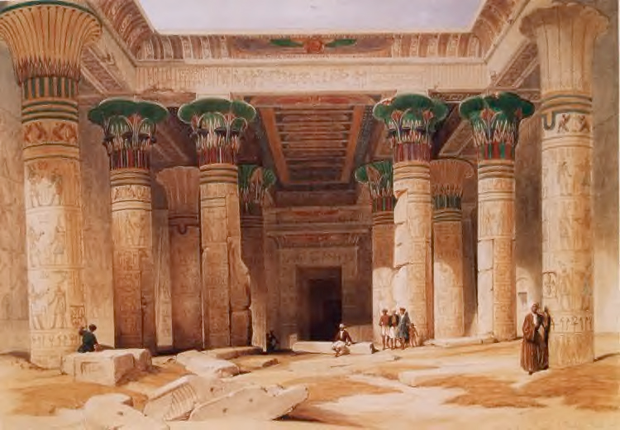

The Nile Valley in Egypt had been inhospitable, but in the seasonally dry channels of the Second Cataract, early farmers learned to manage parts of the river's annual flood. This knowledge could then be applied in Egypt's wide floodplain, giving rise to the great sequence of Upper Egypt's early civilizations. Upper Egypt soon grew wealthy and its culture expanded a gain into Nubia, where renewed southern contacts gave rise to the first of Nubia's trading cultures, called the A-Group. Nubia first became Christian in the time of the Roman emperor Justinian, but soon after, the Muslim Arabs conquered Egypt, and the Nubians were isolated from direct contact with the Christian world north of the Mediterranean. Early attempts at Muslim conquest in Nubia failed, allowing various Christian kingdoms of Nubia to remain independent for centuries, and they even had a profitable treaty arrangement with the Caliph. At times, Christian Nubia became quite powerful and was able to intervene on behalf of the Coptic Christians in Egypt and even to hold territory. In the twelfth century, under Saladin, and later, under the Mamelukes, the power of Christian Nubia was broken by a series of campaigns and invasions of Arab tribes. Copper, gold, objects of shell, and semiprecious stones were traded northward in return for manufactured articles and probably agricultural produce. The conversion to Christianity was a major stimulus to cultural achievement. Christianity required churches, written texts, in Greek, Egyptian Coptic and in Old Nubian, as well as educational and inspirational decoration. The Christian images and symbols were drawn largely from traditions developed in Egypt and the Mediterranean world, but Nubian artists and architects added details, designs, combinations, and proportions of their own to establish a unique formal art.

**Axum/ Aksum**

**Geography and city Development**

People lived in the Ethiopian highlands near the Red Sea, which allowed them to have strategic position in the trade routes between Yemen (in the south of the Arabian peninsula) and the cities of Nubia

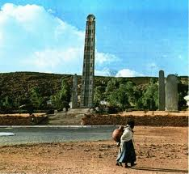

**Ethnicity**

The Aksumites were a people formed from the mix of Kushitic speaking people in Ethiopia and Semitic speaking people in southern Arabia who settled the territory across the Red Sea around 500 BC

**Economy**

 Aksum lay dead in the path of the growing commercial trade routes between Africa, Arabia, and India. As a result, it became fabulously wealthy and its major cities, Adulis, Aksum, and Matara, became three of the most important cosmopolitan centers in the ancient world

**Trade Routes**

The Aksumites controlled one of the most important trade routes in the world and occupied one of the most fertile regions in the world

**Religion**

The Aksumite religion was actually derived from Arabic religion. It was a polytheistic religion which believed that the gods controlled the natural forces of the universe. However, in the fourth century,

**Ezana,**(important leader for converting axum kingdom) who was a folllower of Axumite religion, converted to Christianity under the tutelage of a Syrian bishop named Frumentius. Ezana declared Axum to be a Christian state , thus making it the first Christian state in the history of the world, and began actively converting the population to Christianity.

Ethiopia

**GEOGRAPHY AND CITY DEVELOPMENT**

Deserts to forests highlands.

Mount Ras Deshen-Ethiopia’s highest peak.

Waters of Abbay River feed Lake Tana and flow into Nile.

City of Askum-Ethiopia’s first capital city.

* Located In northern Ethiopia
* Greatest height in 1st and 10th centuries
* Kingdom of great wealth and sophistication
* Controlled caravan routes from the hinterland of Africa

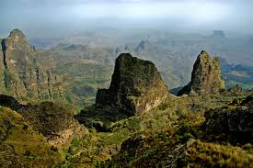

**Economy in Ethiopia**

270 CE Gold coinage used as currency

Crafts and luxury items made

 pottery making,

ivory carving,

glassware production

metalwork

gold, silver, bronze, and iron

**ETHNIC, RELIGIOUS, EDUCATION ISSUES**

They were Christians and were previously based on Judaism.

Frumentius converts the emperor Enzana to Christianity and he becomes first Coptic Bishop of Ethiopia

13 th century 11 churches were made to show political and religious power

Emperor Lalibela was responsible for this and Emperor Lalibela ruled during Zagwe dynasty.

**SIGNIFICANT EVENTS, PEOPLE**

622 CE Ethiopia is being attacked by Muslims

They are surrounded by muslim and pagan kingdoms

They stay strong for 1000 years

Frumentius

Responsible for bringing Christianity to Ethiopia