Welcome to the Swahili Coast
Get these items and enjoy them!!
- Silks
- Axes
- Knives
- Wheat
- Rice
- Glass
- Porcelain
- Gold
- Animal skins
- Elephant tusks
- Rhino horn
- Ambergris
- Fruit
- Salt
Find all these Items/necessities there today!!!!
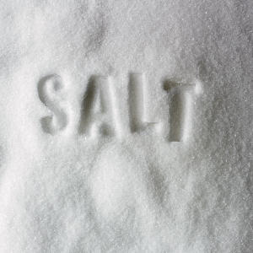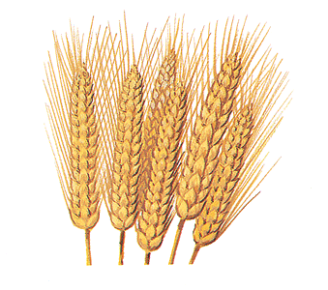

There are amazing geographical features!
- Rivers
- Streams
- Jungles
- The Sea
The town’s people are friendly and are willing to help you any minute!

There are many tribes of which they came from:
- the Rabai,
- the Ribe
- the Giriama
- the Daruma,
- the Chongi,
- the Digo,
- the Jibana,
- the Kauma
- Kambe

