The Sudanic States of Africa
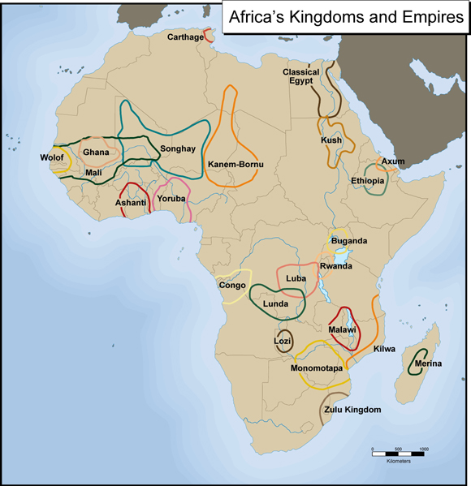
General Information The Sudanic empires of Western Africa were developed south of the Sahara Desert that lasted from 700A.D. to 1500A.D. The strong states were Ghana, Mali and Songhai. The Arabs gave a nickname to this land, and it was called “the land of the blacks’. The Sudanic rulers were the first people in their kingdoms to convert to Islam. Most of the people adopted and followed the religion. This religion was attractive to merchants since they moved from place to place they could practice it anywhere, unlike their indigenous culture. Some people did not want to forget about their religion so they just adopted simple beliefs of Islam, instead of forgetting about their traditional beliefs. Islam helped people see a meaning of life and how to worship, and created festivals.

Ghana-A nickname for the kingdom of Ghana is “the land of gold”. Ghana is known for all their gold mining. They mine gold for economic needs that include wealth and trade. Ghana trades with South Africa, their gold for their salt. They trade their gold since they have no use for it, and because they need salt since it’s scarce in Ghana. The use of iron was important in the Sudanic States. They could use it for trade or build weapons with it. They used it for both options. These two resources helped shape Ghana as a strong state and helped the economic growth. The Ghanaian kings controlled the gold that was mined in their kingdom and placed a system of taxation for their people.
Mali-The founder of the kingdom of Mali was Sundiata Keita. He expanded the kingdom by conquering the kingdom of Ghana and West African gold fields. The most famous king was Mansa Musa, which made a name for himself through his pilgrimage to Mecca. He had sixty thousand people and eighty camels carrying 300 pounds of gold that he took to Mecca. The kingdom of Mali had control over many things that helped their trading/economy. They traded gold for salt and traded with Egypt and the copper mines in East Africa.
Songhay-The first ruler of Songhay was Sonni Ali, which came to power in 1464. He captured Timbuktu and Djenne, as well as the capital of Gao. Mohammed Askia, his successor, came in power in 1493 C.E. He expanded the empire and made a stronger centralized government than the one that Sonni Ali had. He created a new system of laws, made a stronger military, and encouraged learning. The kingdom ended when the Moroccans invaded and conquered them.

