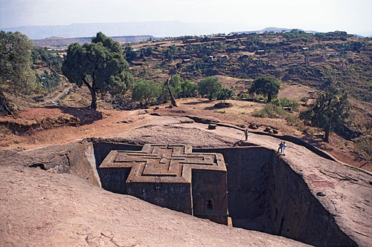

Christian Kingdoms

Religion:

* Orthodox Christians
* Catholics brought from the Portuguese.
* Christians of Egypt
* Axum Has oldest Chritian church in Africa: St. Mary’s
* Had prayer of stones, have greek writing
* Greek culture
* believes that they have the Old Testament in the oldest Christian African church, St.Mary of Zion

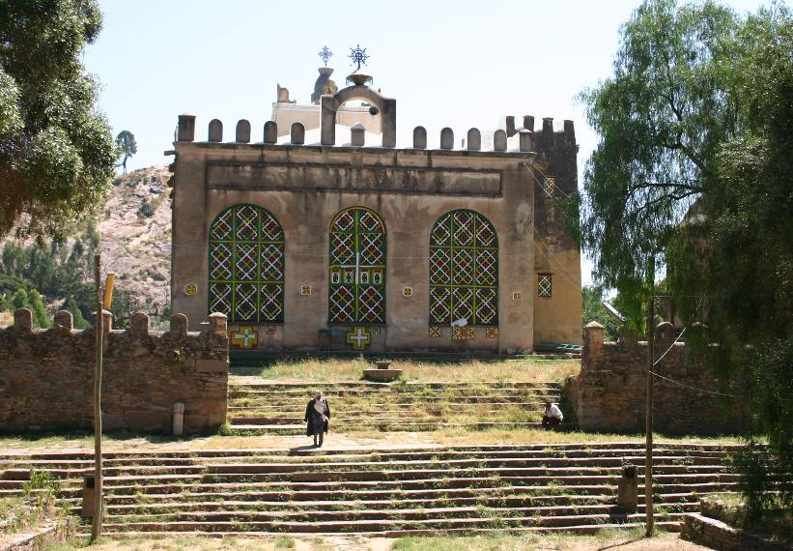

Trade

* Traded with Egypt, Persia, and India. Trading brought cotton, brass, copper, and olive oil.
* Luxury goods of glass crystal, brass and copper to Egypt and to the eastern Roman empire.

Geographical Advantages

* Well suited for agriculture
* Ethiopian highlands served as a highly fortress city

[](http://www.google.com/imgres?imgurl=http://www.wildland.com/trips/details/imagegallery/africa/ETH_simienmnts-sml-Simien2.jpg&imgrefurl=http://www.wildland.com/trips/africa/100081/eth_tripreviews.aspx&usg=__NoekeRrmAVW0trKfwtkuSexHQQM=&h=317&w=475&sz=68&hl=en&start=81&sig2=TaxiaKa_w1i0gH3i2tY3GA&zoom=1&tbnid=_am6FzIUnn_q1M:&tbnh=112&tbnw=164&ei=ZffNTIOMDIOonAfyy534Dw&prev=/images?q=ancient+axum+geography&um=1&hl=en&sa=N&rlz=1R2ADRA_enUS336&biw=1020&bih=544&tbs=isch:1&um=1&itbs=1&iact=rc&dur=187&oei=lPbNTJzxAcT68Aa-hJCPAQ&esq=10&page=6&ndsp=17&ved=1t:429,r:0,s:81&tx=86&ty=72)



**Founded by: Byzantine Empire and Ezana**

**Kingdoms:**

* Axum
* Nubia
* Ethiopia.

Major cosmopolitan cities:

* Axum
* Adulis
* Matara

■Variety of culture Egyptian, Sudanic, Arabic, Middle Eastern, and Indian in the cosmopolitan cities

Economic Advantages

* Red Sea Proximity ideal for trade, access to Indian Ocean
* Seaport attracted merchants from African interior Mediterranean region, Egypt, Arabia, Persia, India