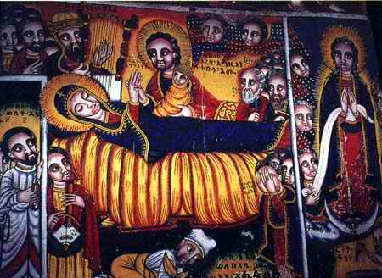

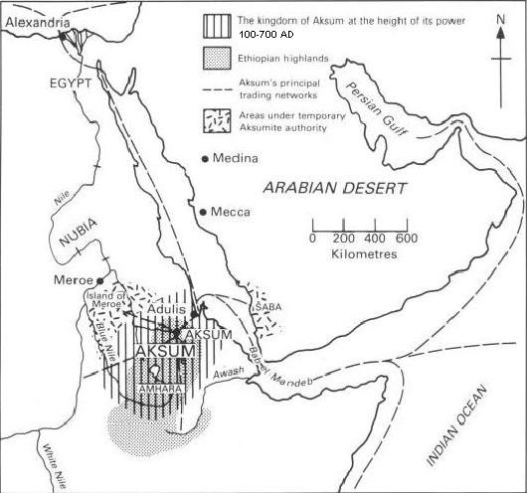

By: Devis Velasquez, Sherry Jiles, and Eduardo Tzapin

Christian Kingdoms

Christian Kingdoms

By: Devis Velasquez, Sherri Jiles, and Eduardo Tzapin

